Ph.D. COMMON ENTRANCE TEST

SUBJECT – ELECTRICAL & ELECTRONICS ENGINEERING
Roll No:
PART B
Duration: 60 minutes Maximum Marks: 50
Instructions:
- This entrance test question paper is not to be taken out of the examination hall
- Question paper consists of Section A and Section B
- Section A consists of 30 MCQs carrying 1 Mark each. Write the Alphabet of the correct answer in the space given.
- Section B consists of Descriptive questions carrying 5 marks each. Restrict your answer to 500 words. Additional plain sheets have been attached to the question paper to answer Section B

SECTION – A
Answer the following questions by writing the Alphabet of the correct answer in the Box given: 30 X 1 = 30

If 1 A current flows in a circuit, the number of electrons flowing through this circuit is
- 0.625 × 10^19
- 1.6 × 10^19
- 1.6 × 10 ^ (- 19)
- 0.625 × 10^ (- 19)

If P is the power of a star connected system then what will be the power of an equivalent delta connected system?
A. P
B. 3P
C. P/3
D. 3/P

KVL works on the principle of
- law of conservation of charge.
- law of conservation of energy.
- both.
- None of the above.

A balanced delta connected load has an impedance of 9∠30o Ω per phase. What is the impedance per phase of its equivalent star?
- 27∠30o Ω
- 30∠30o Ω.
- 3∠30o Ω.
- 20∠30o Ω.
The feedback factor of a Wien bridge oscillator using Op-Amp is
- ⅓
- ¼
- ½
- 1

If the emitter resistance decreases, the
- Q point moves up.
- Collector current decreases.
- Q point stays where it is.
- Current gain increases.

The leakage current in a pn junction is in order of
- A
- kA
- µA
- mA
The base-emitter voltage of the second approximation of a transistor is
- 0 V
- 0.3 V
- 0.7 V
- 1 V

Consider a 200V, 25kW, 30A DC machine lap connected with armature resistance of 0.4 ohms. If the machine is later wave wound, then the developed power is?
- 25kW

- 12.5kW
- 20kW
- 50kW
A synchronous motor is operated at a bus voltage of 1.5 pu and drawing 1.0 pu at zpf leading current. Its synchronous reactance is 0.4 pu. What is the excitation emf of the motor?
- 2.4 p.u.
- 1.5 p.u.

- 1.0 p.u.
- 1.9 p.u.
The condition for maximum power output for an alternator having its load impedance as (2+j) ohms is?
- 26.56°
- 63.43°
- 90°
- 116.56°

4.With constant E,V,Z, the maximum input power can be obtained at load angle of value
_______
- 180-θ
- 90+θ
- θ
- 180

For the unity feedback control system shown in the figure, the open-loop transfer function G(s) given as

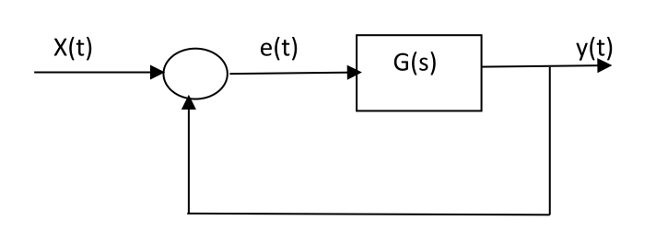

- 0
- 1.0
- 0.5
- Infinity

Which of the following statements is correct for a system with gain margin close to unity or a phase margin close to zero?
- The system is relatively stable
- The system is highly stable
- The system is highly oscillatory
- None of the above

The number of root loci branches which do not terminate at zero is given by,
- The number of zeros
- The number of poles
- The number of zeros + The number of poles
- The number of zeros - The number of poles

When the moving coil in a Dynamometer type wattmeter deflects ________
- pointer doesn’t move
- current flows
- voltage is generated
- pointer moves

In a DVM, a signal conditioning circuit is used ________
- to bring current to a suitable limit
- to bring resistance to a suitable limit
- to bring power to a suitable limit
- to bring voltage to a suitable limit

The sweep generator of a CRO is used to produce
- Saw tooth voltage for the horizontal deflection of electron beam
- Sinusoidal voltage for the vertical deflection of electron beam
- Saw tooth voltage for the vertical deflection of electron beam
- Sinusoidal voltage for the horizontal deflection of electron beam

Which of the following is a type of digital logic circuit?
- Combinational logic circuits
- Sequential logic circuits
- Both Combinational & Sequential logic circuits
- None of the mentioned

Which gates in Digital Circuits are required to convert a NOR-based SR latch to an SR flip-flop?
- Two 2 input AND gates
- Two 3 input AND gates
- Two 2 input OR gates
- Two 3 input OR gates

A negative current is used to turn off which of the following power
electronic device
- SCR
- GTO
- MOSFET
- IGBT

In a simple square wave inverter which of the following cannot be
controlled
- Voltage
- Current
- Frequency
- Switching Time
Which of the following converter supports four quadrant operation of a
DC drive
- Fully Controlled Rectifier
- Class D Chopper
- Class E Chopper
- Semi Converter

Which of the following SCR rectifier circuits will have a poor power factor.
- Rectifier with Resistive load and firing angle of 45 degrees
- Rectifier with R-L load and firing angle of 30 degrees
- Rectifier with Resistive load and firing angle of 90 degrees
- Rectifier with RL Load and firing angle of 60 degrees

A single-phase load is supplied by a single-phase voltage source. If the current flowing from the load to the source is theA and if the voltage at the load terminals is then
- load absorbs real power and delivers reactive power.

- load absorbs real power and absorbs reactive power.
- load delivers real power and delivers reactive power.
- load delivers real power and absorbs reactive power

Which one of the following is not true in HDFC transmission?
- Corona loss is much more in HVDC transmission.
- The power transmission capability of bipolar line is almost the same as that of single-circuit ac line.
- HVDC link can operate between two AC systems whose frequencies need not be equal.

- There is no distance limitation for HVDC transmission by underground cable.
In the following network, the voltage magnitudes at buses are equal to 1 p.u. The voltage phase angles are very small, and the line resistances are negligible. All the line reactances are equal to j1Ω. The voltage phase angles in rad at buses 2 and 3 are
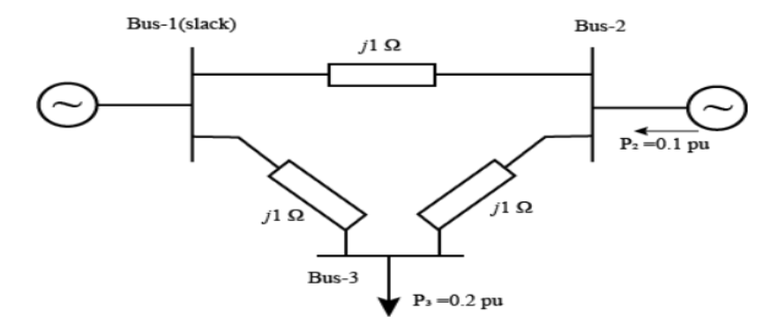

- θ 2 = −0.1, θ 3 = −0.2
- θ 2 = 0, θ 3 = −0.1
- θ 2 = 0.1, θ 3 = 0.1
- θ 2 = 0.1, θ 3 = 0.2

If the base impedance and the line-to line base voltage are 100 ohms and 100kV respectively, then the real power in MW delivered by the generator connected at the slack bus is
- -10
- 0
- 10
- 20

Which of the following systems is time invariant?
- y(t) = x(2t) + x(t)
- y(t) = x(t) + x(1-t)
- y(t) = -x(t) + x(1-t)
- y(t) = x(t) + x(t-1)

30 State whether the integrator system is stable or not.
- Unstable
- Stable
- Partially Stable
- All of the mentioned

Section - B
Answer any four questions (Each question carry 5 marks 4*5 = 20

1. Find the current passing through the 5 ohm resistor (encircled in red color) and comment on the method which is easier compared to difficult ones (Mesh Analysis and Nodal Analysis only).

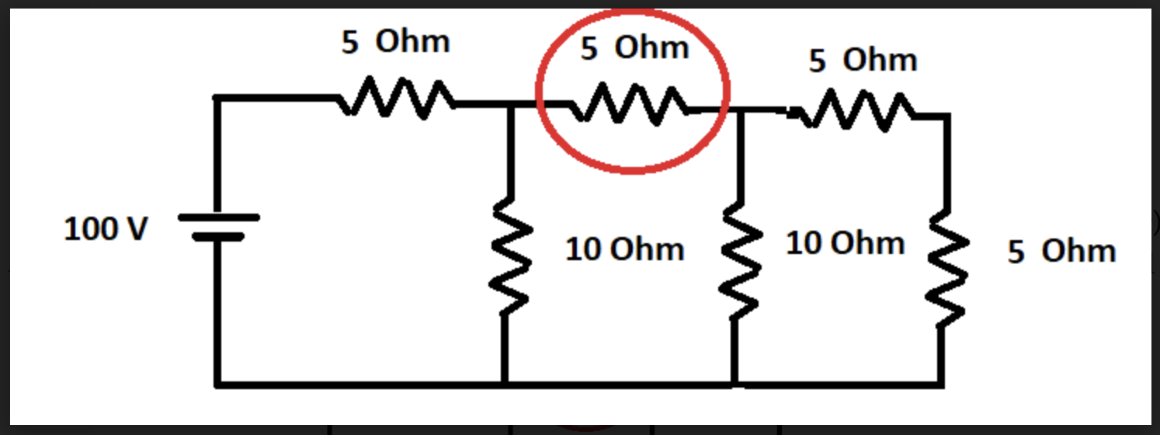

2. Illustrate in detail the role of Electrical Machines in Steel Rolling Mills with neat diagram.
3. The first two rows in the Routh table for the characteristic equation of a certain closed
loop control system is given as
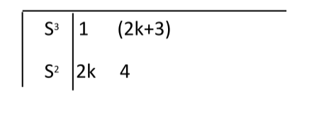
The range of K for which the system is stable is
- -2.0<K<0.5
- 0<K<0.5
- 0<K<Infinity
- 0.5<K<Infinity

4. A synchronous generator is connected to an infinite bus with excitation voltage Ef = 1.3 pu. The generator has a synchronous reactance of 1.1 pu and is delivering real power (P) of 0.6 pu to the bus. Assume the infinite bus voltage to be 1.0 pu. Neglect stator resistance. The reactive power (Q) in pu supplied by the generator to the bus under this condition is____________

5. Describe the classifications of signals and systems.

6. Draw the circuit of a dual converter and explain how it can be operated as a cyclo
converter with suitable illustrations.

**********

